**FUNDAMENTALS OF DATA ANALYSTS WITH TABLEAU**

**PROJECT TITLE**

**POLITICAL JUGGERNAUTS A QUANTITATIVE ANALYSIS OF CANDIDATES IN THE 2019 LOK SABHA ELECTIONS**

**NAAN MUDHALVAN PROJECT ID:**

**NM2023TMID27696**

**TEAM MEMBERS**

1. **M. SUBHA SRI [TEAM LEADER]**
2. **R. HEMADHARSHINI**
3. **M. JOTHIKA**
4. **S. JOTHIKA**



**PG AND RESEARCH DEPARTMENT OF PHYSICS**

**RAJA DORAISINGAM GOVERNMENT ARTS COLLEGE**

**SIVAGANGAI-630561**

**A QUANTITATIVE ANALYSIS OF CANDIDATES IN THE 2019 LOK SABHA ELECTIONS**

INTRODUCTION

1.1 Overview

The Lok Sabha is composed of representative of people chosen by direct election on the basis of universal Adult Suffrage. The lok Sabha, as per the provision of Article 79 of Indian Constitution, the House of the people, the lower house of the Parliament.

1.2 Purpose

In a Parliamentary form of government the most important purpose of the lower house is Control Over The Executive. The Parliament which is made up of all representatives together, controls and guides, the Government. Lok Sabha is about passing the bills and Laws for this smooth running of the country.

PROBLEM DEFINITION &DESIGN THINKING

2.1 Empathy Map

First we make a empathy map for a group idea. To create a empathy map go to mural website and logic with email account and search the templates that you wanted to create.

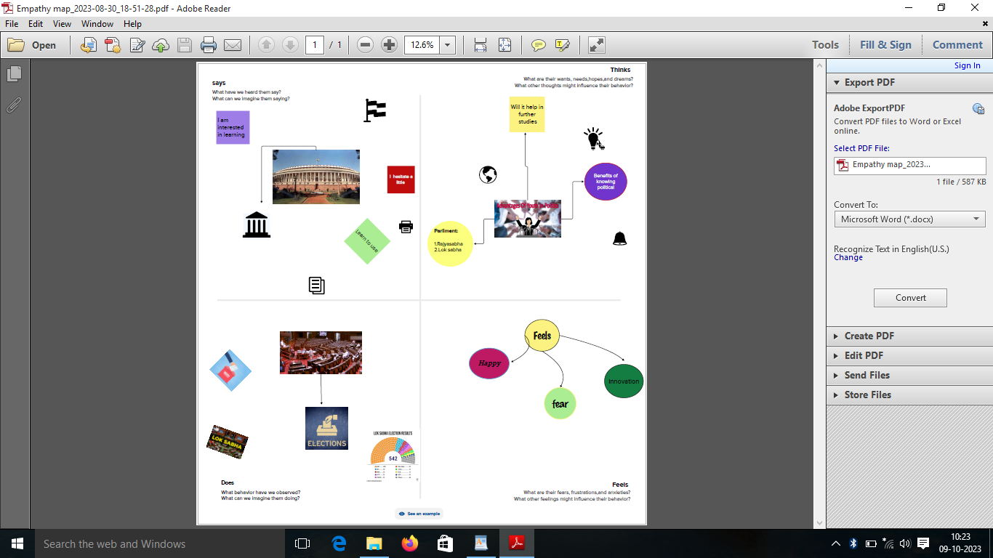

2.2 Ideation & Brainstorming Map

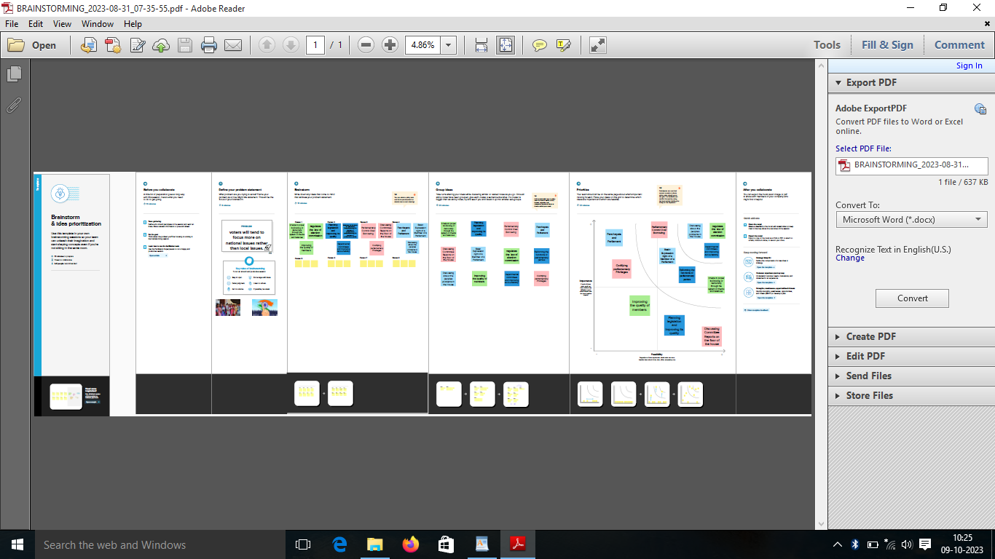

Make a Brainstorm map with mural website, in brainstorm we discussed the define problem and understanding the problem. First we have defined what are the problems and types in the question box.

Then it is a group idea and is written in the box person 1, person 2 and person 3, person 4 now four person give different idea for problem.

Take best three idea and type in the last box.

RESULT

Before opening the tableau desktop we had download the dataset for our project.

After download the dataset we open the tableau desktop.

After opening the option selected connect to data, select the MORE option and select the dataset.

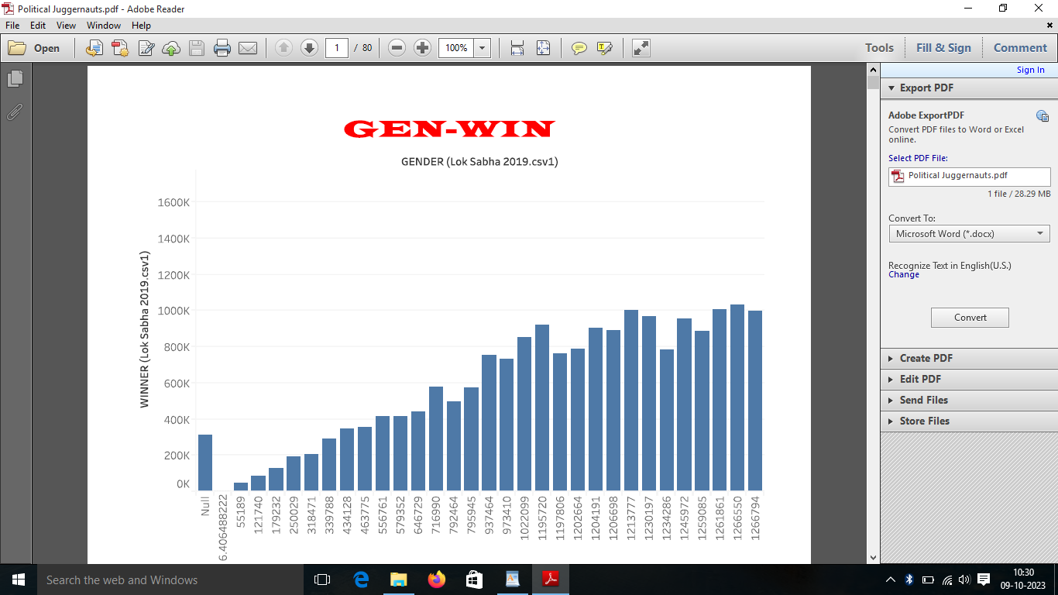

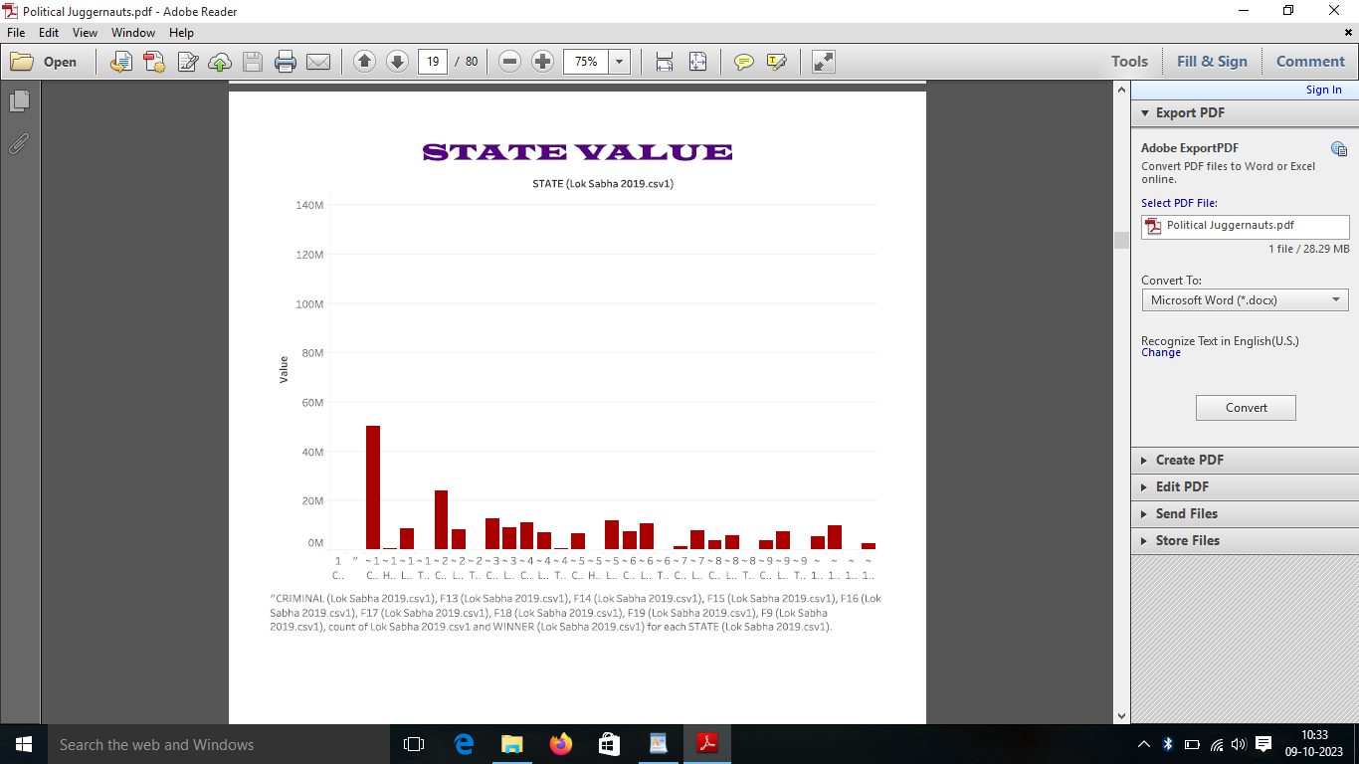

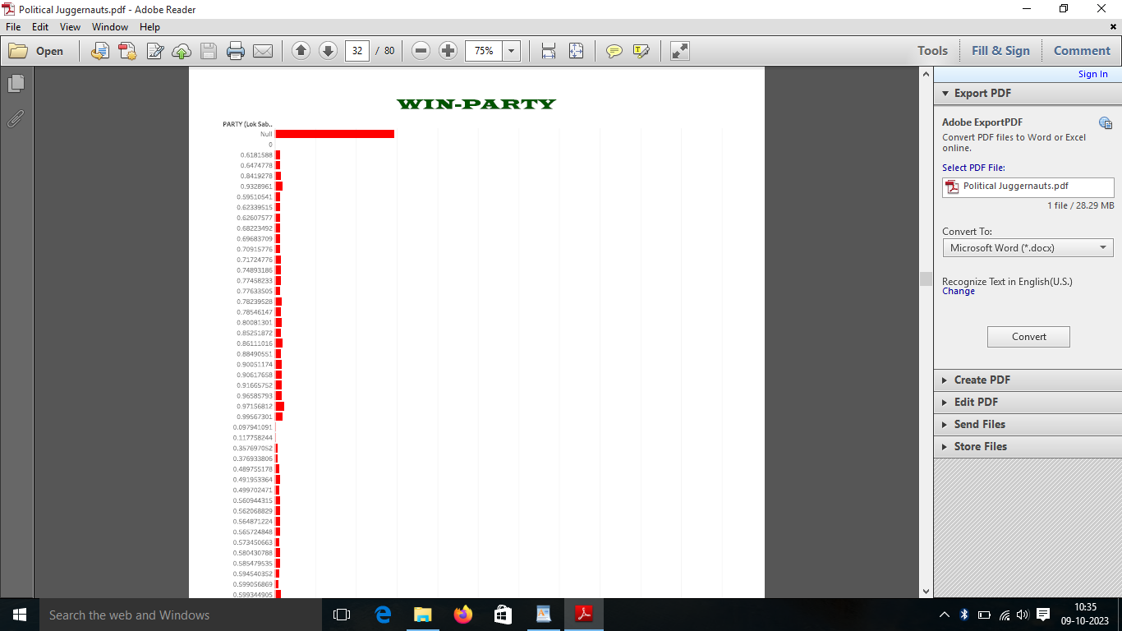

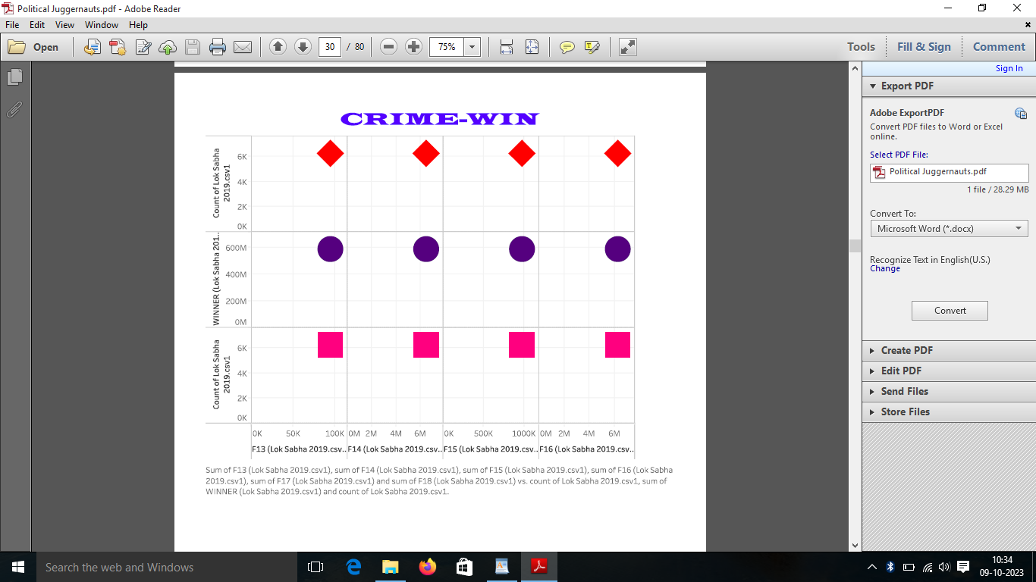

After finishing the analysis data, add a dashboard.

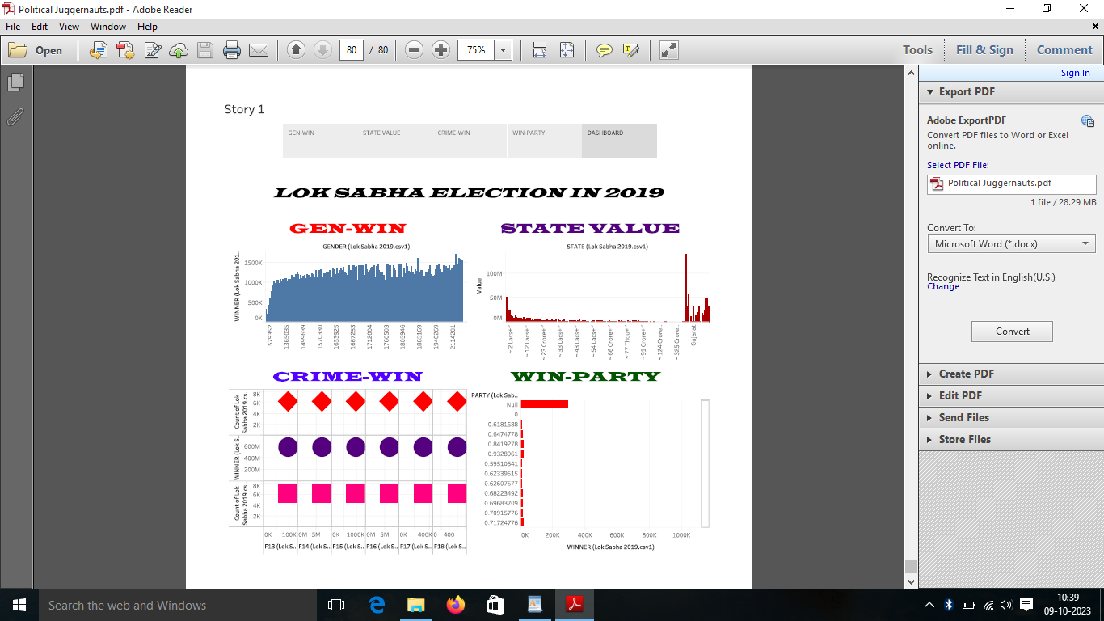

We created a story in the tableau desktop.

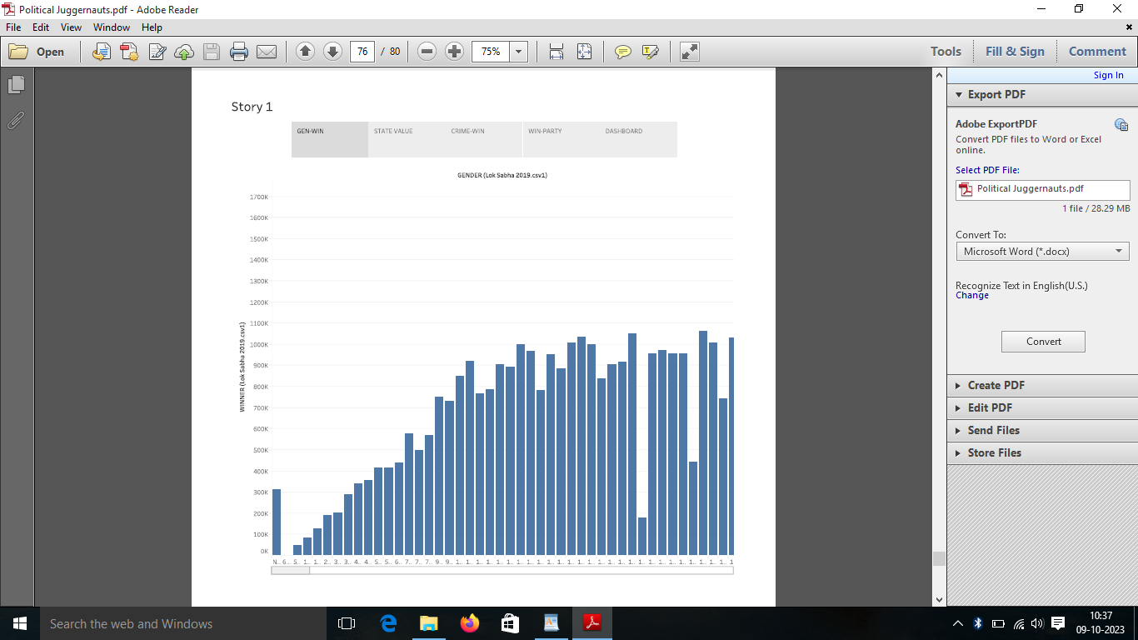

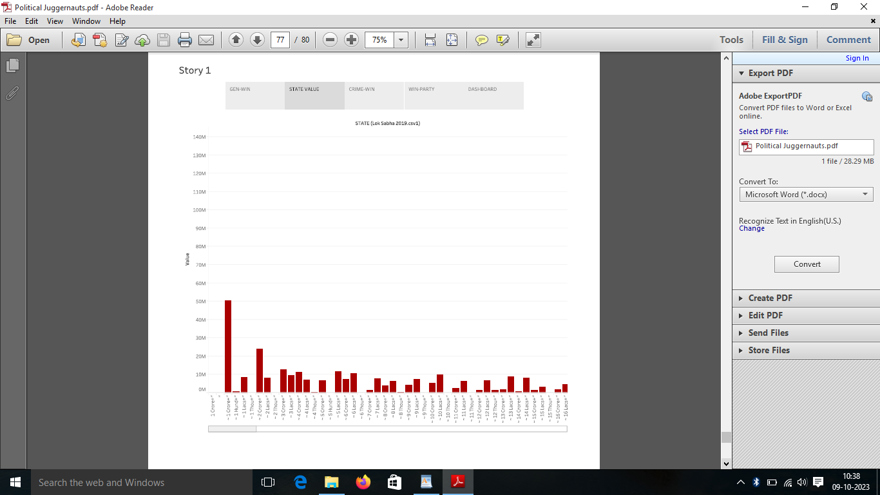

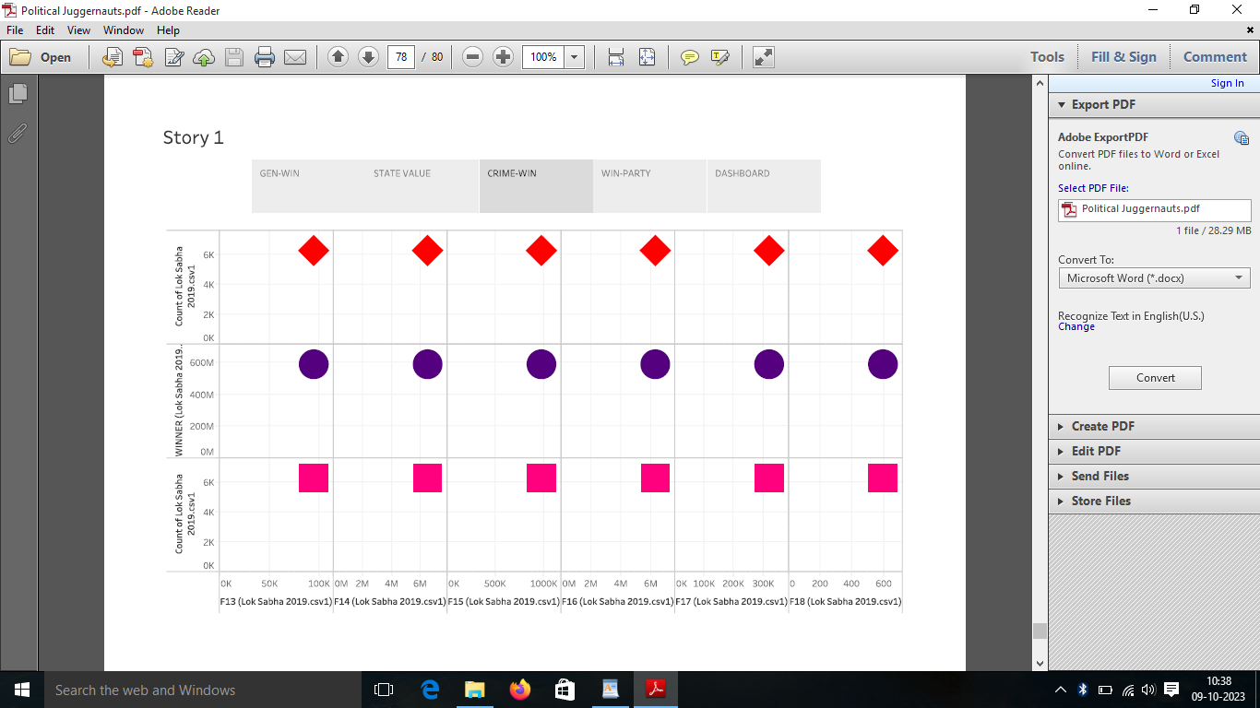

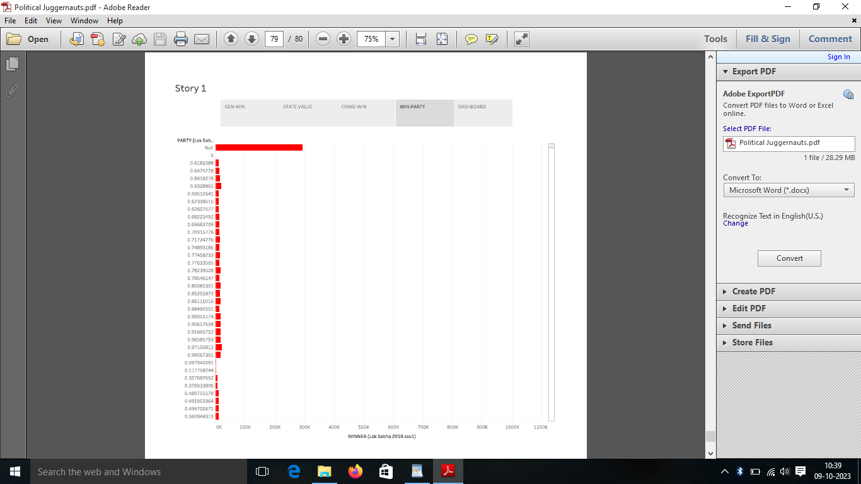

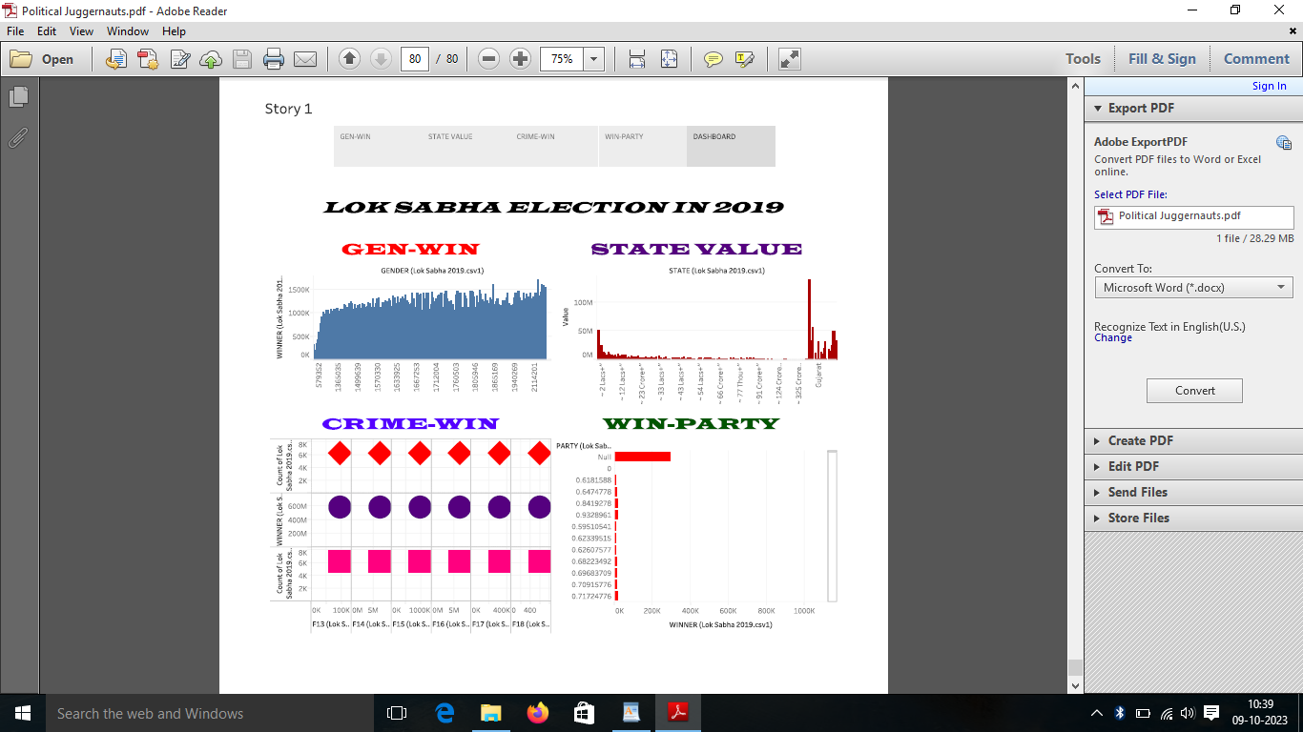

Sign into the tableau account.

Publish the workbook in the tableau cloud.

Upload the project in the githup.

ADVANTAGES

It helps in proper functioning of democracy through the system of checks and balances.

It controls the despotism of the government. Money builds can be only introduced in the Lok Sabha.

DISADVANTAGES

The access trial period limits only for fourteen days.

APPLICATIONS

It is very easy to apply the date analysis and visualization to creates a view based on the fields already used to selected in data pane.

CONCLUSION

General Elections were held in India in seven phases from 11 April to 19 May 2019 to elect the members of the 17th lok sabha. Votes were counted and the result was declared on 23rd May. The election resulted in a landslide victory for BJP won 303 seats to formed the Government.

FUTURE SCOPE

Easy to analysis the data of the lok sabha election in 2019 for public sector and other purposes.